Object Oriented programming-II |Introduction Of OOP

- OOP is a popular programming approach used to develop programs in a structured and reusable way. Java is mainly based on the OOP concept.
Object-Oriented Programming (OOP) is a programming approach that organizes a program using classes and objects. It combines data and methods into objects to make programs easier to develop and manage.

Main Features of OOP:
- Class – A blueprint for creating objects.
- Object – An instance of a class.
- Encapsulation – Binding data and methods together.
- Inheritance – Acquiring properties and methods from another class.
- Polymorphism – One interface/method can have different forms.
- Abstraction – Hiding unnecessary implementation details.

Difference Between SPL/SPM and OOP
SPL | OOP
Focuses on functions/procedures. | Focuses on objects and classes.
Data and functions are generally separate. | Data and methods are combined in objects.
Does not mainly support inheritance and polymorphism. | Supports inheritance and polymorphism.
Data security is comparatively lower. | Provides better data security through encapsulation.
Code reusability is limited. | Provides better code reusability.
Suitable for small and simple programs. | Suitable for large and complex programs.
Example: C. | Example: Java, C++, C#.

Structured / Procedure Programming Methodology (SPM) OR SPL
SPM is a programming approach where a program is divided into functions or procedures. It mainly focuses on steps and functions to solve a problem.
Example: C, Pascal, Fortan.
Structured/Procedure Programming Methodology (SPM) is a programming methodology in which a program is organized into a set of procedures or functions that operate on data to perform specific tasks.

Basic Features of SPM/SPL
- Emphasis is placed on algorithms.
- Large programs are divided into smaller parts called functions.
- Most functions share global data.
- Data moves globally from one function to another.
- Functions transfer data from one form to another.
- It follows a top-down approach to programming.

Limitations of SPM
- It reaches its limit when the project becomes too large.
- Large programs become more complex and difficult to manage.
- Functions have unrestricted access to global data.
- It provides less data security.
- Code reusability is limited compared to OOP.
- Making changes to one part of a large program may affect other parts.
- It does not support important OOP features like inheritance, polymorphism, and encapsulation.
- Maintaining and debugging large programs becomes difficult.

OOP History — Important Points
- The concept of OOP came into the picture in the 1970s.
- Smalltalk was the first purely object-oriented programming language.
- Smalltalk was developed by Alan Kay.
- Popular OOP languages include Java, C#, PHP, Python, and C++.
- Examples of pure OOP languages include Ruby, Scala, and JADE.
- Languages primarily designed for OOP include Java, Python, and C++.

Importance / Benefits of OOP
- Code Reusability – Existing code can be reused through inheritance.
- Data Security – Encapsulation protects data from unauthorized access.
- Easy Maintenance – Programs are easier to modify and maintain.
- Modularity – Large programs can be divided into smaller classes and objects.
- Flexibility – Polymorphism allows the same method to perform different tasks.
- Easy Debugging – Errors can be found and fixed more easily.
- Reduces Complexity – Abstraction hides unnecessary implementation details.
- Suitable for Large Projects – OOP is useful for developing large and complex software.

Why Java is Not a Pure OOP Language?
Java is not considered a pure Object-Oriented Programming (OOP) language because it supports primitive data types that are not objects.
Main Reason:
Java has 8 primitive data types:
byte, short, int, long, float, double, char, Boolean
For example: int x = 10;
Here, x is a primitive value, not an object.
In a pure OOP language, everything should be treated as an object.
Other Reasons
- Primitive data types are not objects
  - int, char, boolean, etc. are not objects.
- Static members can be used without creating objects
Math.sqrt(25);
We can call a static method using the class name without creating an object.
- Wrapper classes are provided to make primitives objects
Integer x = 10;
Here Integer is an object, but int itself is not.
Java is not a pure OOP language because it supports primitive data types such as int, char, boolean, etc., which are not objects. In a pure OOP language, everything should be treated as an object. Java also supports static members that can be accessed without creating objects.

Or another short answer
Java is not a pure Object-Oriented Programming (OOP) language because:
- Java supports primitive data types such as int, char, float, double, and boolean, which are not objects.
- Java allows static methods and variables to be used without creating an object.
- Java supports primitive operations directly.
Example:
int x = 10;
Here, x is a primitive data type, not an object.
Conclusion:
Since everything in a pure OOP language should be treated as an object, Java is considered object-oriented but not purely object-oriented.
What is Object-Oriented Analysis (OOA)?
Object-Oriented Analysis (OOA) is the process of analyzing a system by identifying its objects, classes, attributes, and relationships based on the requirements of the system.
Object-Oriented Analysis is a method of analyzing and modeling a system in terms of objects and classes to understand its requirements and structure.

Concepts of OOP
According to the given image, the basic concepts of OOP are:
- Object – An instance of a class that represents a real-world entity.
- Class – A blueprint or template used to create objects.
- Instance Variables – Variables that belong to an object and store its individual data/state.
- Methods – Functions defined inside a class that describe the behavior or actions of an object.

- Object
An object is a real-world entity or an instance of a class that has state (data) and behavior (methods).
Example:
Student s1 = new Student ();
Here, s1 is an object of the student class.
- State: Name, ID, age
- Behavior: Study, attendClass(), takeExam()

An object is an instance of a class that contains data and methods to represent the state and behavior of an entity

- Class
A class is a blueprint or template used to create objects. It defines the data (variables) and behavior (methods) of objects.
Here, Student is a class. Objects can be created from this class.
class Student {
String name;
int id;

void study() {
System.out.println("Student is studying");
}
}
A class is a blueprint or template for creating objects that defines their data members and methods.

- Methods
- A method is basically a behavior or action of an object.
- A class can contain many methods.
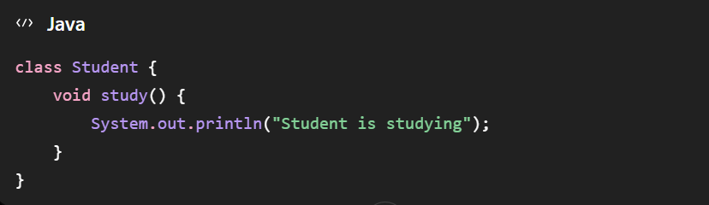
- Methods contain the logic of a program, manipulate data, and perform different actions.
Here, study() is a method that represents the behavior of the Student object.
A method is a block of code defined inside a class that represents the behavior of an object and performs a specific action.

Instance Variables
- Instance variables are variables that belong to an object.
- Each object has its own unique set of instance variables.
- For example, a Box can have:
  - Height
  - Width
  - Depth
- These are the instance variables of the Box object.
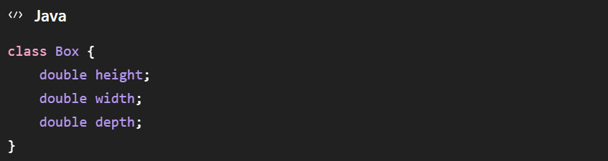
- The state of an object is determined by the values assigned to its instance variables.

Here, height, width, and depth are instance variables.
Instance variables are variables associated with an object that store its data or state. Each object has its own copy of these variables.

UML: Unified Modeling Language
UML (Unified Modeling Language) is a standard visual modeling language used to visualize, design, and document the structure and behavior of a software system.
Main Points
- UML uses diagrams to represent a software system.
- It helps developers understand and design the system before coding.
- It is commonly used in Object-Oriented Analysis and Design (OOAD).
UML is a standard visual modelling language used to specify, visualize, construct, and document the components and design of a software system.

Four Basic Features of OOP
The four basic features of Object-Oriented Programming (OOP) are:
- Encapsulation – Binding data and methods together into a single unit (class) and protecting the data from direct access.
- Abstraction – Hiding unnecessary implementation details and showing only the essential features.
- Inheritance – Allowing one class to acquire the properties and methods of another class.
- Polymorphism – Allowing the same method or interface to perform different actions in different situations.

- Abstraction
Abstraction is an OOP concept that represents the essential features of an object while hiding its unnecessary implementation or background details from the user

In simple words, abstraction means hiding unnecessary details from the user and showing only the important information.
Example: Car
A car user needs to know how to:
- Start the car
- Accelerate
- Brake
- Steer
The user does not need to know how the engine, transmission, or internal mechanisms work.

- Encapsulation
Encapsulation is an OOP concept that combines data and methods into a single unit (class) and protects the data from unauthorized direct access.

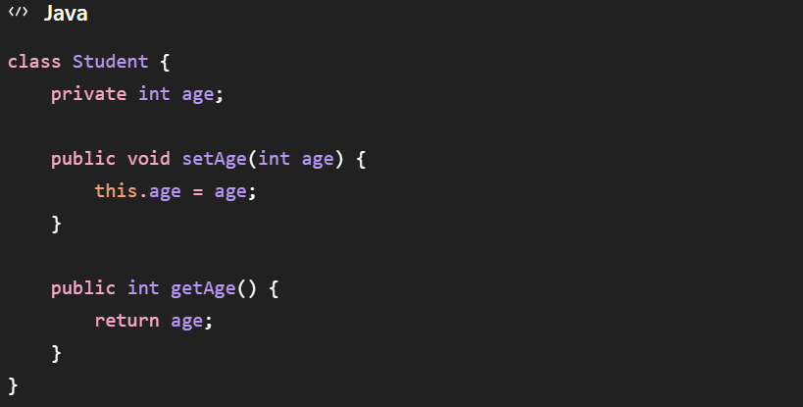
Here, age is kept private, so it cannot be accessed directly from outside the class. It is accessed through setAge() and getAge() methods.

- Inheritance
Inheritance is the mechanism by which a new class acquires the properties and methods of an existing class, allowing code reusability.

The existing class is called the parent/superclass, and the new class is called the child/subclass.
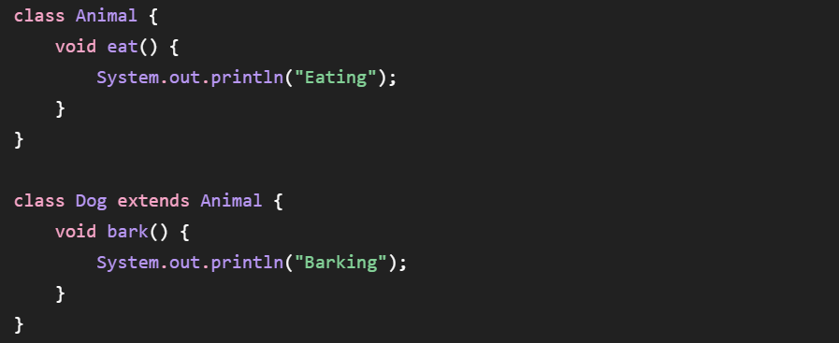
Here, Dog inherits the eat() method from Animal.
Advantages
- Code reusability
- Reduces code duplication
- Makes programs easier to maintain and extend

- Polymorphism
Polymorphism is the ability of an object or method to take multiple forms and perform different behaviors in different situations.

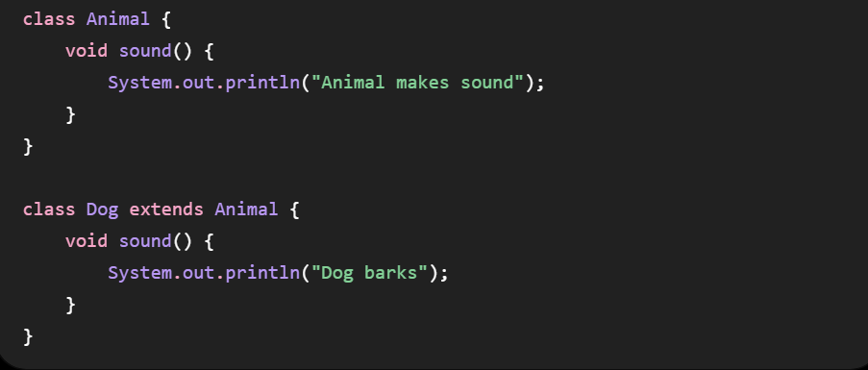

Here, the same method sound() behaves differently for different objects.
Types of Polymorphism
- Compile-time Polymorphism – Method overloading
- Run-time Polymorphism – Method overriding

